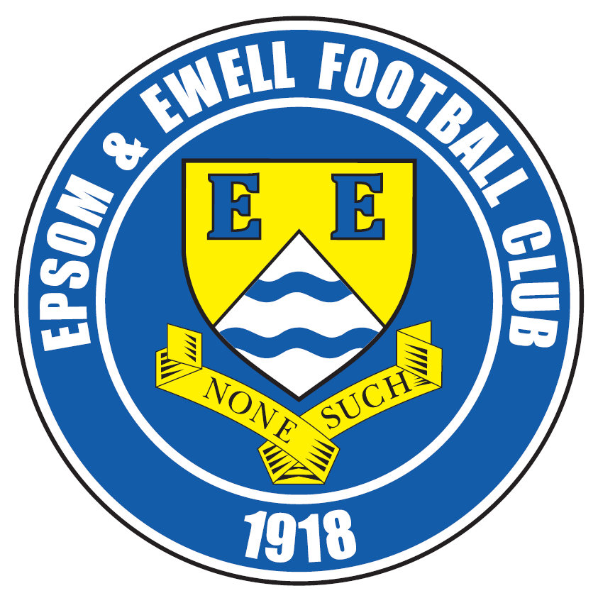 | Epsom & Ewell F.C.  11  v  Chessington & Hook United  Saturday, 7th November 2015
Good afternoon! After a two week break we are back in League action, hopefully fresh, fit and raring to go again! We welcome the players, supporters and officials of Chessington & Hook United, together with today’s officials and our regular faces. They will be very familiar with the journey, having visited Chipstead just four days previously for a Surrey Senior Cup tie!

As usual, there are many connections across both clubs with former players James Deacons, Russ Banyard (also our Coach), J Flack, Sam Hewitt and long serving Antony “Freddie” Myers all in their ranks today. It is particularly good to see that Sam is back playing again after he suffered a nasty injury here a couple of years back when in our colours against Three Bridges in the F.A. Cup.

Recent matches against our opponents have not produced many positive results for us and although we didn’t meet last season, we face them today not having won any of our previous four home matches between the sides; all four having been lost by the odd goal with the score having been 0-1 in our last three home losses.

If we are to maintain our current excellent League form we need to reverse that particular trend immediately. Having two weeks off is handy sometimes but it does enable many other sides to catch and pass us in the League table. Fortunately few clubs have done this, so as a result we cannot afford to slip up today as we did against Chertsey when we last returned from a break.

Since that defeat we hosted Dorking Wanderers in the Surrey Senior Cup and were heavily beaten 6-1. However, it is fair to say that the county competition is very low on our list of priorities and no one was particularly shedding a tear over the defeat. Clearly our boys were able to focus on the League match that followed it at Ashford Town (Mx) and produced the performance of the season so far to win 3-2 there. I actually thought we deserved more than the single goal win, but you don’t always get what you deserve in football and maybe we kept some goals in the bank for our January rematch in the League Cup!

Following today’s match we travel to Knaphill on Saturday for another important League fixture and three days after that will do battle at title favourites Hartley Wintney who have been setting the League alight with eleven straight wins. However, there is no point looking ahead to that match if we don’t get the business done against Chessington and Knaphill first, and we must remember that both clubs are currently in the top half of the table themselves, so neither will be easy!

I will finish today by reminding regular supporters that we are in desperate need of sponsorship; both for matches and for players. Please help your club, as every penny we get in sponsorship reduces the amount we have to take from our gradually depleting resources!

Enjoy the game!

Rich

You can now follow us on Facebook www.facebook.com/epsomandewellfc or Twitter @EEFCOfficial

Cover Photos v Ashford Town by Gemma Jarman

- Our leading striker Kyle Hough is so good he even scores while lying down!
- Matt Farrell’s header leaves the Ashford keeper flat footed for our opener


Cherry Red Records Combined Counties League
Premier Division Table 2015/16
inc Tuesday 3rd November | P | W | D | L | F | A | Pts | GD | H | A
Hartley Wintney | 11 | 11 | 0 | 0 | 42 | 9 | 33 | +33 | 30/1 | 17/11
Ashford Town (Mx) | 15 | 11 | 0 | 4 | 33 | 19 | 33 | +14 | 30/4 | 3-2
Camberley Town | 14 | 9 | 3 | 2 | 21 | 12 | 30 | +9 | 16/4 | 20/2
Epsom & Ewell | 12 | 8 | 3 | 1 | 29 | 11 | 27 | +18 | X | X
Horley Town | 14 | 8 | 2 | 4 | 34 | 18 | 26 | +16 | 27/2 | 28/12
Hanworth Villa | 13 | 8 | 1 | 4 | 24 | 18 | 25 | +6 | 21/11 | 23/4
Chessington & Hook | 15 | 7 | 2 | 6 | 29 | 31 | 23 | -2 | 7/11 | 19/3
Guildford City | 15 | 7 | 1 | 7 | 34 | 37 | 22 | -3 | 5/12 | 2/4
Raynes Park Vale | 16 | 7 | 0 | 9 | 35 | 34 | 21 | +1 | 3-1 | 28/3
Spelthorne Sports | 16 | 6 | 3 | 7 | 29 | 33 | 21 | -4 | 16/1 | 6-2
Knaphill | 13 | 6 | 1 | 6 | 22 | 15 | 19 | +7 | 12/3 | 14/11
Colliers Wood United | 17 | 6 | 1 | 10 | 35 | 32 | 19 | +3 | 3-1 | 28/11
Westfield | 13 | 5 | 4 | 4 | 18 | 18 | 19 | 0 | 26/3 | 0-0
AFC Hayes | 15 | 6 | 1 | 8 | 22 | 23 | 19 | -1 | 1-1 | 9/1
Windsor | 13 | 4 | 6 | 3 | 20 | 26 | 18 | -6 | 2-2 | 23/1
Farnham Town | 13 | 5 | 2 | 6 | 25 | 18 | 17 | +7 | 1-0 | 6/2
Sutton Common Rovers | 13 | 4 | 1 | 8 | 23 | 32 | 13 | -9 | 19/12 | 2-1
Badshot Lea | 14 | 4 | 1 | 9 | 19 | 41 | 13 | -22 | 9/4 | 12/12
Chertsey Town | 14 | 3 | 3 | 8 | 11 | 22 | 12 | -11 | 0-1 | 5/3
Bedfont Sports | 12 | 2 | 5 | 5 | 16 | 17 | 11 | -1 | 13/2 | 24/11
Redhill | 13 | 3 | 2 | 8 | 22 | 30 | 11 | -8 | 2/1 | 1-0
Cove | 13 | 1 | 0 | 12 | 6 | 53 | 3 | -47 | 8/12 | 7-0

Lucky Day? – 7th November
Played 14 - W 6 D 3 L 5 - F 19 A 20 - PPG 1.50 - Average
Our Club record against Chessington & Hook United
Played 26 - W 10 D 9 L 7 - F 51 A 41 - PPG 1.50 - Average
Largest wins and losses
20th August 1974 - W 6-0 - League - 30th August 2008 - L 1-3 - League
Last visit
Saturday 14th September 2013 - L 0-1 - Combined Counties League

Club Manager - Glyn Mandeville
Good afternoon everyone. I would like to welcome the players, staff and supporters of Chessington & Hook United to today's game.

Due to a work commitment I was unable to be at Ashford Town for our great 3-2 win and I would like to say a big thank you to Matt Smith, Alex McKay, Steve Eacott and Jimmy Hendry for their help.


This result shows just what we are capable of, and hopefully we can keep our good form up as we have some tough matches coming up, starting right now.

We know that Chessington & Hook are a good side that will battle all the way and we will have to be at our best today if we are to claim the points today.

I hope you enjoy today’s game and have a safe trip home. Thank you for your support.

Manders

Club Captain - Sam Currie
Good afternoon and welcome to today's game against Chessington and Hook, and in particular any of the old faces we have seen in and out of their squad in previous weeks (Freddie Myers).

Although our last result was a good one away at the league leaders, we are now looking to improve our home track record today against Chessington -and having played them on numerous occasions in my time in the Combined Counties League they will no doubt be up for the task ahead and prove a stern challenge.

Although we beat Ashford we know that in this league your home performances are as, if not more, important and we will be looking to pick up as many points here at High Road over the forthcoming months, making this a bit of a fortress and build up another unbeaten run that will hopefully see us still in the mix after Christmas.

We have a strong belief in the squad and the feeling is good for this afternoon.

As always it goes without saying- we thank you all for your generous support.


We hope that the Chessington and Hook United fans, players and staff have a safe journey home following the game.

Sam

Latest Results and Fixtures
Surrey Senior Cup 2nd Round – Tuesday 20th October
Camberley Town | 1-1 | Knaphill
No extra time in this competition – Knaphill won 3-2 on penalties
Epsom & Ewell | 1-6 | Dorking Wanderers
Combined Counties League – Tuesday 20th October
Chessington & Hook United | 2-1 | Colliers Wood United
Raynes Park Vale | 0-2 | Farnham Town
Combined Counties League – Friday 23rd October
Hanworth Villa | 0-4 | Redhill
Combined Counties League – Saturday 24th October
AFC Hayes | 5-0 | Cove
Ashford Town (Mx) | 2-3 | Epsom & Ewell
Camberley Town | 0-2 | Sutton Common Rovers
Chertsey Town | 1-3 | Bedfont Sports
Chessington & Hook United | 3-9 | Guildford City
Colliers Wood United | 1-2 | Badshot Lea
Farnham Town | 3-4 | Windsor
Knaphill | 0-1 | Hartley Wintney
Spelthorne Sports | 2-2 | Horley Town
Westfield | 4-2 | Raynes Park Vale
Surrey Senior Cup 2nd Round – Tuesday 27th October
Ashford Town (Mx) | 3-1 | Beckenham Town
Combined Counties League – Tuesday 27th October
AFC Hayes | 2-4 | Hartley Wintney
Chertsey Town | 1-0 | Raynes Park Vale
Chessington & Hook United | 2-1 | Bedfont Sports
Horley Town | 0-3 | Guildford City
Combined Counties League – Wednesday 28th October
Colliers Wood United | 3-4 | Hanworth Villa
F.A. Vase First Round – Saturday 31st October
Bedfont Sports | 1-4 | Carterton
Bowers & Pitsea | 3-2 | Hanworth Villa
Cove | 0-5 | Canterbury City
Eastbourne Town | 3-2+ | Farnham Town
Hartley Wintney | 3-1 | Wokingham & Emmbrook
Kidlington | 2-2+ | Ashford Town (Mx)
Knaphill | 5-4+ | Cray Valley (PM)
Lancing | 1-2 | Camberley Town
Windsor | 3-2 | Croydon
Worthing United | 0-1 | Sutton Common Rovers
Combined Counties League – Saturday 31st October
Badshot Lea | 0-3 | Spelthorne Sports
Latest Results and Fixtures
Combined Counties League – Saturday 31st October
Raynes Park Vale | 4-1 | AFC Hayes
Westfield | 2-4 | Colliers Wood United
F.A. Vase First Round Replay – Tuesday 3rd November
Ashford Town (Mx) | 1-3 | Kidlington
Surrey Senior Cup Second Round – Tuesday 3rd November
Chipstead | 4-1 | Chessington & Hook United
Woking | 10-0 | Sutton Common Rovers
Combined Counties League – Tuesday 3rd November
Bedfont Sports | 1-1 | Farnham Town
Hartley Wintney | 4-1 | Spelthorne Sports
Combined Counties League – Saturday 7th November
Bedfont Sports | V | Guildford City
Chertsey Town | V | Sutton Common Rovers
Colliers Wood United | V | AFC Hayes
Cove | V | Camberley Town
Epsom & Ewell | V | Chessington & Hook United
Farnham Town | V | Ashford Town (Mx)
Hanworth Villa | V | Hartley Wintney
Horley Town | V | Westfield
Knaphill | V | Badshot Lea
Raynes Park Vale | V | Windsor
Redhill | V | Spelthorne Sports
Surrey Senior Cup Second Round – Tuesday 10th November
Godalming Town | V | Guildford City
Combined Counties League – Tuesday 10th November
Bedfont Sports | V | Hartley Wintney
Redhill | V | Farnham Town
Windsor | V | Cove
Combined Counties League – Saturday 14th November
AFC Hayes | V | Chertsey Town
Ashford Town (Mx) | V | Redhill
Bedfont Sports | V | Cove
Camberley Town | V | Farnham Town
Chessington & Hook United | V | Horley Town
Hanworth Villa | V | Raynes Park Vale
Hartley Wintney | V | Westfield
Knaphill | V | Epsom & Ewell
Spelthorne Sports | V | Colliers Wood United
Sutton Common Rovers | V | Badshot Lea
Windsor | V | Guildford City
Combined Counties League – Tuesday 17th November
Farnham Town | V | Westfield
Latest Results and Fixtures
Combined Counties League – Tuesday 17th November
Farnham Town | V | Westfield
Hartley Wintney | V | Epsom & Ewell
F.A. Vase Second Round – Saturday 21st November
Colliers Wood United | V | Loxwood
Hartley Wintney | V | Windsor
Knaphill | V | Tunbridge Wells
Newhaven | V | Camberley Town
Sutton Common Rovers | V | AFC CA / Beckenham Town
Combined Counties League – Saturday 21st November
Badshot Lea | V | Guildford City
Chertsey Town | V | Cove
Epsom & Ewell | V | Hanworth Villa
Horley Town | V | Bedfont Sports
Raynes Park Vale | V | Spelthorne Sports
Westfield | V | Chessington & Hook United

Player Profile – Number 7 – Kyle Hough
Our latest player profile is from our long serving striker Kyle Hough.

He joined us in 2007, having previously been with former Manager Lyndon Buckwell at Corinthian Casuals, and ever since has been attacking the opposition’s goal, not to mention our record books.

He holds numerous club records for penalties, having on one occasion scored an incredible 27 in a row and also holds the seasonal record with nine; a feat he has accomplished on three occasions. However, he has also scored many great goals from open play and is bearing down on second place on the all-time scoring list, held by Reg Marlow who has 254. At Kyle’s current rate he is only two years away from passing him!

Age: 27

Position: Striker

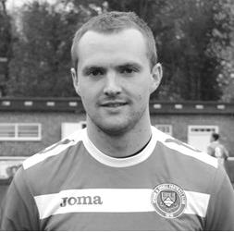
Club supported: Horley Town!!

Favourite Food: Pizza

Favourite Film: Toy Story

Messi or Ronaldo: Messi

Favourite Drink: Beer

Favourite Ground played at: Horley Town!!

Best moment for Epsom: Winning the League Cup

Describe the Gaffa in three words: Hero – Sexy – Slim

Kyle’s Playing Stats: Debut 14/08/07 - Appearances: 310 - Sub: 15 - Total: 325 - Goals: 182

First Eleven Appearances - (max 16 – including Ashford Town – 17/10/15)
Name | Debut | 2014/15 |  |  |  | Career Totals
Name | Debut | App | Sub | Total | Goals | App | Sub | Total | Goals
AJAYI Tayo | 22/08/2015 | 0 | 2 | 2 | 0 | 0 | 2 | 2 | 0
COOPER-SMITH Daryl | 03/01/2015 | 9 | 4 | 13 | 4 | 18 | 7 | 25 | 10
CURRIE Sam | 04/08/2012 | 13 | 1 | 14 | 0 | 121 | 10 | 131 | 2
DAVISON Conor* | 22/08/2015 | 1 | 2 | 3 | 0 | 1 | 2 | 3 | 0
DEAN Dan | 02/08/2014 | 14 | 0 | 14 | 0 | 50 | 1 | 51 | 0
DEWAR Ali | 29/10/2011 | 0 | 0 | 0 | 0 | 55 | 35 | 90 | 10
EACOTT Michael | 02/08/2014 | 14 | 0 | 14 | 0 | 60 | 0 | 60 | 0
FARRELL Matt | 02/08/2014 | 15 | 0 | 15 | 3 | 56 | 3 | 59 | 10
FERDINANDO Matt | 20/09/2014 | 9 | 0 | 9 | 1 | 36 | 4 | 40 | 7
GRIFFIN Reisse | 08/08/2015 | 5 | 1 | 6 | 0 | 5 | 1 | 6 | 0
HASTINGS Craig | 08/08/2015 | 9 | 3 | 12 | 0 | 9 | 3 | 12 | 0
HENDRY Rob | 08/08/2015 | 14 | 1 | 15 | 5 | 14 | 1 | 15 | 5
HOUGH Kyle | 14/08/2007 | 14 | 0 | 14 | 11 | 310 | 15 | 325 | 182
JONES Adrian | 06/08/2011 | 1 | 0 | 1 | 0 | 21 | 0 | 21 | 0
KURDZIEL Jakub | 29/08/2015 | 1 | 0 | 1 | 0 | 1 | 0 | 1 | 0
MARVELL Dale* | 15/01/2000 | 8 | 4 | 12 | 1 | 269 | 49 | 318 | 86
MCGREGOR Alex | 08/08/2009 | 7 | 2 | 9 | 2 | 179 | 58 | 237 | 29
MCKAY Alex | 20/12/2008 | 9 | 1 | 10 | 0 | 94 | 27 | 121 | 8
NEALE Thomas | 13/10/2015 | 1 | 3 | 4 | 0 | 1 | 3 | 4 | 0
NEILL David* | 03/10/2015 | 1 | 1 | 2 | 0 | 1 | 1 | 2 | 0
NORTH Rhys | 16/08/2015 | 2 | 6 | 8 | 0 | 2 | 6 | 8 | 0
OLIVER Beckett | 29/08/2015 | 2 | 5 | 7 | 0 | 2 | 5 | 7 | 0
PANAYIOTOU Savvas* | 03/01/2015 | 2 | 0 | 2 | 0 | 18 | 3 | 21 | 3
SMITH Matt | 08/08/2009 | 0 | 0 | 0 | 0 | 91 | 43 | 134 | 10
TANTON Matt | 02/08/2014 | 13 | 0 | 13 | 0 | 31 | 4 | 35 | 1
TAYLOR James | 26/08/2013 | 11 | 2 | 13 | 0 | 67 | 10 | 77 | 3
Own Goal |  |  |  |  |  |  |  |  | 1
* Player has left the club

From behind the goal
Epsom & Ewell 1-6 Dorking Wanderers
Surrey Senior Cup - First Round - Tuesday 20th October 2015

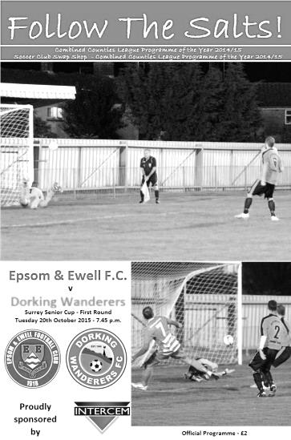
Salts handed lesson by rampant Wanderers

Not that long ago, our boys were at the top of the League. Supporters and no doubt players too were talking about the possibility of actually winning the League. Whilst I believe that achievement is still possible, we all received a harsh lesson on the sort of standard we will come up against, should we ever get there, as Dorking Wanderers provided an example of flowing football that at times cut us to pieces.

Following their loss to Molesey three days earlier, our opponents fielded a strong side with a couple of new faces at the back in an attempt to gain some sort of response. Our priorities were different and with a couple of players still recovering from injuries, they were given the night off ahead of our more important League game at Ashford Town on Saturday.

As a result, both Dan Dean and Sam Currie were missing from our line-up, which resulted in Rhys North coming in at right back with James Taylor moving from there to partner Craig Hastings in the centre. Additionally Rob Hendry, Daryl Cooper-Smith and Alex McGregor returned to the starting line-up in place of Dale Marvell, Thomas Neale and Conor Davison who were on the bench.

The first ten minutes of the match were fairly even, but a 12th minute goal appeared to knock our confidence significantly as Tom Tolfrey shredded our defence and knocked the ball past the exposed Michael Eacott, and we looked very wobbly back there from that point. We were rarely able to relieve the pressure and mount credible threats of our own. Kyle Hough curled a shot towards the far corner after 17 minutes but was off target and McGregor's free kick a few minutes later was dealt with capably by their custodian Gary Ross, but we produced little else of note and appeared a little in awe of our opponents.

Eacott was forced into a good low save as we began to struggle with their movement and the game got away from us in a two minute spell just before the break. After 40 minutes Phil Page made a run down the right and from the edge of the area unleashed a great low strike that flew past Eacott into the bottom corner

and shortly after this a misdirected crossfield ball from Alex McKay went straight to the third member of their highly rated front line in Kev Terry, and he cut inside North and drilled the ball into the corner from the edge of the box. By half time, the game was over and everyone knew it.

There was no let up as the lead was extended after 50 minutes. A low shot from distance was well blocked by Eacott but Matthew Briggs was first to the loose ball and knocked it in. They probably should have extended the lead from a free kick which was met by a solid header but Eacott was there again. We were in real danger at this point although nearly pulled a goal back when McKay got to Neale's low corner first and prodded the ball towards goal only to see his effort blocked on the line and after 70 minutes we were sliced apart with the ball played into the channel between centre back and full back which Briggs ran onto and dispatched clinically.

To our credit we then started to ask a few questions. Hough did well on the left before laying the ball back to McGregor whose shot from just over twenty yards was heading for the bottom corner but deflected wickedly off a defender and the ball only just missed the opposite post. After 80 minutes we had a goal back. Matt Farrell intercepted the ball in midfield and ran straight at goal, enabling Hough to find space to his right. Farrell's pass was spot on as was Hough's low finish.

However, this only seemed to annoy the opposition who underlined their superiority by scoring a sixth goal in identical circumstances to their fifth, just three minutes later; this time with Tolfrey the recipient and a seventh nearly followed from a similar move but the ball ended up in the side netting. At the other end substitute Beckett Oliver had a good strike from the edge of the area well saved, although Hough was able to retrieve the loose ball and set Farrell up, but his goalbound effort was tipped over the bar by Ross.

In summary we looked quite lively when we went forward, but these threats were few and far between as we came up against a very good side in fine form with the inevitable result.

In recent years we have played some higher standard sides in this competition, most of which have chosen to play little more than a development team against us. At least yesterday's opponents took the game seriously and hopefully we will learn from some of the lessons that were given out, starting on Saturday.

Team: Michael Eacott, Rhys North, Matt Tanton, James Taylor, Craig Hastings, Alex McKay (c), Rob Hendry, Matt Farrell, Kyle Hough, Daryl Cooper-Smith, Alex McGregor

Subs: Thomas Neale for Cooper-Smith (46), Beckett Oliver for Hendry (79)

Club Records - 7th November
Date | Day | Competition |  | Opponents |  | Scorers
07/11/25 | Sat | Surrey Senior Cup 3q | H | Godalming | 3-2 | R.Marlow (2), T.Edwards
07/11/31 | Sat | Amateur Cup 3q | H | Merton | 2-0 | H.Payton, T.Dunne
07/11/36 | Sat | Amateur Cup 3q | A | Redhill | 0-3
07/11/53 | Sat | Corinthian League | A | Uxbridge | 0-2
07/11/64 | Sat | Amateur Cup 3q | H | BAC Weybridge | 1-2 | G.Richardson
07/11/70 | Sat | Athenian League 2 | H | Harrow Borough | 1-3 | K.Ireland
07/11/73 | Wed | Southern Combination Cup 1 | A | Woking | 3-1 | T.Tuite (3)
07/11/81 | Sat | Isthmian League 1 | H | Clapton | 1-0 | J.Hunn (pen)
07/11/87 | Sat | Isthmian League 2s | A | Flackwell Heath | 2-1 | J.Richardson (pen), M.Elliott
07/11/92 | Sat | Isthmian League 3 | A | Flackwell Heath | 0-0
07/11/95 | Tue | Isthmian League 3 | A | Aveley | 2-0 | G.Meakin, M.Laverty
07/11/98 | Sat | F.A. Vase 1 | H | Stansted | 1-1+ | J.Tome
07/11/04 | Sun | Isthmian League 2 | H | Flackwell Heath | 2-4 | C.Read (2)
07/11/09 | Sat | Combined Counties  Premier Division | A | Raynes Park Vale | 1-1 | K.Hough
Historical Decades
Date | Day | Competition |  | Opponents |  | Scorers
90 years ago – Epsom Town F.C.
07/11/25 | Sat | Surrey Senior Cup 3q | H | Godalming | 3-2 | R.Marlow (2), T.Edwards
80 years ago – Epsom F.C.
09/11/35 | Sat | London League | H | Carshalton Athletic | 1-3 | L.Green
70 years ago – Epsom F.C.
10/11/45 | Sat | London League | H | Acton | 12-0 | G.Brogdale (4), S.Scott (2), R.Buller (2), R.Crowther (2), J.Jones, S.Tingey
60 years ago – Epsom F.C.
05/11/55 | Sat | Amateur Cup 2q | H | Malden Town | 2-1 | G.Cairns, J.Berry
50 years ago – Epsom & Ewell F.C.
06/11/65 | Sat | Amateur Cup 3q | H | Petter Sports | 4-1 | P.Deadman (3), F.Fondyke
40 years ago – Epsom & Ewell F.C.
08/11/75 | Sat | Athenian League 2 | A | Camberley Town | 3-3 | T.Tuite (2), P.Butler
30 years ago – Epsom & Ewell F.C.
05/11/85 | Tue | Isthmian League Premier Division | H | Sutton United | 2-2 | T.Tuite, K.Duffell
20 years ago – Epsom & Ewell F.C.
07/11/95 | Tue | Isthmian League 3 | A | Aveley | 2-0 | G.Meakin, M.Laverty
10 years ago – Epsom & Ewell F.C.
05/11/05 | Sat | Isthmian League 2 | A | Croydon | 0-3

History Corner – 7th November
90 years ago today we edged past Godalming by three goals to two in the Surrey Senior Cup. Reg Marlow scored twice while the other goal was scored by regular defender Tom Edwards who was playing up front in an experimental line up. We would eventually reach the last 16 of the competition where we bowed out 2-4 at home to a well-known Athenian League team called Summerstown. Two years later though that team had ceased to exist!

84 years ago today Merton were defeated 2-0 at West Street with goals from Harry Payton and Tommy Dunne as we attempted to improve on our Amateur Cup run of the previous season when we had reached the last 64. We would eventually do this, reaching the last 32 of the national competition before bowing out at the home of the holders Wycombe Wanderers. We would never reach this stage again.

70 years ago this week we registered the largest League win in our history as Acton were crushed by 12 clear goals at West Street. Gordon Brogdale was the main threat, scoring four of the goals as part of a spell in which he scored 30 times in just 15 appearances.

He actually scored four goals the following week too becoming one of only two players in club history to score four times in consecutive weeks (Bill Goddard). He actually scored four goals on seven separate occasions for us, which is brought into perspective when you realise that only two players, Andy Boxall (1996) and Joao Tome (1998) have achieved this once in the last thirty years!

However, there was a sting in the tail. Acton were clearly in trouble and following an astonishing 22-0 defeat at Guildford City Reserves a few weeks later, they folded and their results were removed, so the 12-0 win never appeared in the League table!

50 years ago this week Peter Deadman scored a hat trick as we defeated Petter Sports 4-1 in an Amateur Cup tie. He was a young lad playing in a very average side, so it’s hard to know whether anyone else recognised the potential of a player who would go on to play over 40 times for the England Amateur team, becoming one of Hendon’s all time legendary players through the sixties and seventies. As a forty year old he even scored against us in 1985 when Grays Athletic dumped us out of the F.A. Trophy in a replay at the Recreation Ground. Alongside the names of Chris Kelly and Larry Pritchard goes another fantastic player that we let slip during that awful decade.

32 years ago today Tommy Tuite scored his second hat trick for the club; his second in four days, as Woking were defeated 3-1 at Kingfield in the Southern Combination Cup. Tommy would go on to get another 31 during his time at our club!

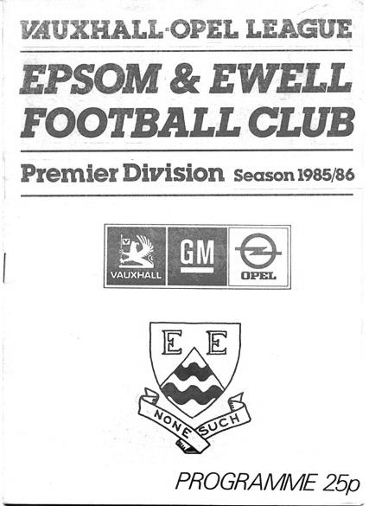
30 years ago this week we managed a 2-2 draw at home to Sutton United in an Isthmian League Premier Division match. We were trailing 2-1 but had a free kick just outside the penalty area. Kevin Duffell’s shot was blocked but it rebounded to him on his weaker left foot and he lashed it into the top corner to earn us a point. I remember it like it was yesterday! (see programme left)

28 years ago today young central defender Matt Elliott headed the winning goal as we won 2-1 on our first ever visit to Flackwell Heath. I wonder what happened to him!

From behind the goal
Ashford Town (Mx) 2-3 Epsom & Ewell
Combined Counties League Premier Division - Saturday 24th October 2015

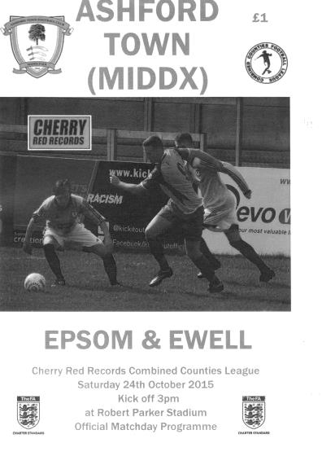
Away day joy tempered by injury to Hough

Under ominous, leaden skies we faced our first contest this season against a team in the top four when visiting the Robert Parker Stadium to do battle with table topping Ashford Town (Mx) but came through with flying colours, showing great attacking threat at first and great defensive cohesion when it was required.

The first item of note on the team sheet was that Dan Dean was still unable to play, having picked up an injury at Banstead. However, Sam Currie was back as was Matt Ferdinando, while on the left Beckett Oliver started the game and our two wingers gave us balance and width throughout the match. Dale Marvell and Alex McGregor were absent while Daryl Cooper-Smith was on the bench but not really ready to go as he was still troubled with injury too. Still, it was a lot better than our previous visit to Ashford in January when we just had the Manager and Assistant Manager on the bench!

We had a scare in the opening minutes when a clever one-two put their leading scorer Dan Fleming through but he pulled his shot across goal and out for a goal kick. It would not be long before he was regretting that miss as we then took charge for a while. Craig Hastings put a Ferdinando corner just over the bar whilst a low Currie cross from the right reached Matt Farrell but his shot was well blocked by the covering defender Samid Kazi.

Under the circumstances it wasn't surprising when we took the lead in the tenth minute and although Oliver's left foot cross had the pace taken out of it by a defender's header, it still had enough momentum to reach Farrell, lurking in space at the near post ten yards out and his header just dropped under the bar to put us one-nil up.

The home defence looked as solid as a house of cards on a windy day just then and less than a minute after conceding, a terrible decision by their defender to play a back pass had terminal consequences as Kyle Hough got there just ahead of Tyler Tobin, and in the ensuing collision between striker and keeper the ball bounced off Hough and dribbled over the line. Unfortunately Hough hurt his knee quite badly in the incident and took no further part in the game, and we just have to hope that he is able to play

again when we next take the field after our break.

At 2-0 up but now with Tom Neale on in place of our leading scorer we could have gone into our shell, but a challenge by Ferdinando set up Currie in the area and he ran on to the ball and casually smashed it into the top corner at the near post after 17 minutes to send the away fans into raptures.

Ok lads, 3-0 up, don't do anything silly to hand the momentum over. Oops! Just three minutes later Currie was at the other end but scuffed his routine back pass to Michael Eacott who was left totally exposed as Jack Beadle ran around him with the ball to open the home team's account. It was only the second goal we have conceded in the opening half of a league match this season, yet three minutes later they had another when a good break on the right ended with a shot smashing back out from Eacott's left hand post and when it was fed back in deeper, the ball was retrieved at the far post and the cross forced in by Kazi.

Game on! I was already thinking back to the last two games at Cove (1993) and Worthing (1984) where we had lost in ninety minutes after holding a three goal lead but I should have had more faith. Having said that, I suspect that if you had told anyone in the crowd that after a mad opening 25 minutes there would be no further goals in the game they wouldn't have believed you!

There were of course moments of concern. Matt Tanton and Fleming both picking up yellow cards on the half hour for the sort of thing that would have seen them sent off on another day, but if anything we were the closer of the two teams to scoring again after Alex McKay's long throw was headed less than a foot wide of the near post by Hastings with the defence flat footed.

The second half would teach us a lot about our players and whether they had the character and resilience to withstand the inevitable home barrage that was expected. The answer was a positive and resounding "yes". The excellent McKay and Farrell were everywhere, protecting our back four and hassling the opposition into mistakes and we actually created the better chances in the second half too. Rob Hendry intercepted a header back to Tobin and prodded his shot towards goal, only to see it roll agonisingly wide of the post. In fact, as they pressed for an equaliser we were frequently able to hit them on the break and probably should have extended our lead from one of those opportunities.

All in all though an excellent three points from our boys, and I must include a quick note for the opposition skipper Russell Canderton. With five minutes remaining and the home side desperate for an equaliser, McKay was injured and despite their situation, he sportingly knocked the ball out of play so that our man could receive treatment. A classy touch and we look forward to meeting them twice more later this season in League and League Cup matches.

Team: Michael Eacott, Sam Currie © Matt Tanton, James Taylor, Craig Hastings, Alex McKay, Beckett Oliver, Matt Farrell, Kyle Hough, Rob Hendry, Matt Ferdinando

Subs: Tom Neale for Hough (14), Reisse Griffin for Oliver (73)

Centre page for results

Centre page for results



CCL Premier Division Club Directory
A.F.C. HAYES Telephone: 0208-845-0110 - Ground: Farm Park, Kingshill Avenue, Hayes, Middx. UB4 8DD - Colours: Blue and White Stripes/Blue/Blue

ASHFORD TOWN (Mx) Telephone: 01784-245908 - Ground: The Robert Parker Stadium, Short Lane, Stanwell, Middx. TW19 7BH - Colours: Tangerine & White Stripes/Black/Tangerine

BADSHOT LEA Telephone: 01252-320385 - Ground: Ash United FC, Shawfield Stadium, Youngs Drive, Shawfields Road, Ash, Hampshire. GU12 6RE - Colours: Claret/White/Claret

BEDFONT SPORTS Telephone: 0208-831-9067 - Ground: Bedfont Sports Club, Hatton Road, Bedfont, Middx TW14 8JA - Colours: Red & Black Hoops/Black/Red & Black Hoops

CAMBERLEY TOWN Telephone: 01276-65392 - Ground: Krooner Park, Wilton Road, Camberley, Surrey. GU15 2QW - Colours: Red & White Stripes/Blue/Red

CHERTSEY TOWN Telephone: 01932-561774 - Ground: Alwyns Lane, Chertsey, Surrey. KT16 9DW - Colours: Royal Blue & White Stripes/Royal Blue/Royal Blue

CHESSINGTON & HOOK UNITED Telephone: 01372-602263 - Ground: Chalky Lane, Chessington, Surrey. KT9 2NF - Colours: Blue/Blue/Blue

COLLIERS WOOD UNITED Telephone: 0208-942 8062 - Ground: Wibbandune Sports Ground, Robin Hood Way, Wimbledon. SW20 0AA - Colours: Blue & Black Stripes/Black/Black

COVE Telephone: 01252-543615 - Ground: Oak Farm Fields, 7 Squirrel Lane, Cove, Farnborough, Hampshire. GU14 8PB - Colours: Yellow/Black/Yellow

EPSOM & EWELL Telephone: 01737-553250 - Ground: Chipstead FC, High Road, Chipstead, Surrey. CR5 3SF - Colours: Royal Blue & White Hoops/Royal Blue/Royal Blue & White Hoops

FARNHAM TOWN Telephone: 01252-715305 Ground: Memorial Ground, Babbs Mead, West Street, Farnham, Surrey. GU9 7DY Colours: - Claret & Sky Blue /White/ Claret & Sky Blue

GUILDFORD CITY Telephone: 01483-443322 - Ground: The Spectrum, Parkway, Guildford, Surrey. GU1 1UP - Colours: Red & White Stripes/Black/Black

HANWORTH VILLA Telephone: 0208-831-9391 - Ground: Rectory Meadows, Park Road, off Hounslow Road, Hanworth, Middlesex. TW13 6PN - Colours: Red & White Stripes/Black/Black

HARTLEY WINTNEY Telephone: 01252-843586 - Ground: Memorial Playing Fields, Green Lane, Hartley Wintney, Hants RG27 8DL - Colours: Orange & Black/ Orange /Orange

HORLEY TOWN Telephone: 01293-822000 - Ground: The New Defence, Anderson Way, Court Lodge Road, Horley, Surrey. RH6 8SP - Colours: Claret & Sky Blue/Claret/Claret

KNAPHILL Telephone: 01483-475150 - Ground: Brookwood Country Park, Redding Way, Lower Guildford Road, Knaphill, Surrey. GU21 2AY - Colours: Red/Black/Red

SUTTON COMMON ROVERS Telephone: 01932-866386 - Ground: Sutton United FC, Gander Green Lane, Sutton, Surrey SM1 2EY - Colours: Yellow/Black/Black

RAYNES PARK VALE Telephone: 020-8540-8843 - Ground: Prince Georges Playing Field, Grand Drive, Raynes Park, London. SW20 9NB - Colours: Blue/Blue/Red

REDHILL Telephone: 01737-762129 - Ground: Kiln Brow, Three Arch Road, Redhill, Surrey RH1 5AG - Colours: Red and White Stripes/Black/Red

SPELTHORNE SPORTS Telephone: 01932-961055 - Ground: Spelthorne Sports Club, 296 Staines Road, Ashford Common, Ashford, Middx. TW15 1RY - Colours: Light & Dark Blue/Dark Blue/Light Blue

WESTFIELD Telephone: 01483-771106 - Ground: Woking Park, Kingfield Road, Woking, Surrey. GU22 9BA - Colours: Yellow/Black/Black

WINDSOR Telephone: 01753-860656 - Ground: Stag Meadow, St Leonards Road, Windsor, Berks SL4 3DR - Colours: Red/Red/Red

Chessington & Hook United – History
Formed as Chessington F.C. in 1921, the club entered the Kingston & District League and within two years were the Division Four Champions. Further honours proved elusive as they rose through the divisions until 1961 when they won the Premier Division.

By 1968, the club had moved to the Premier Division of the Middlesex League, which was their first taste of intermediate football. They finished that first season as Runners-up and were consequently admitted to the Surrey County Senior League – a major milestone in the club’s history. Even more significantly, we became Division One Champions in the 1970-71 season.

Despite the successes of the late 70’s, the club’s fortunes declined alarmingly in the early 80’s. Relegation to the Surrey Premier League was quickly followed by further demotion to the Surrey Combination. Bankruptcy was a real possibility.

The introduction of a new management team, led by Chairman Graham Ellis, saw a rebirth of the club and a return to former glory, now to be known as Chessington & Hook United F.C. By 1994, they were back in the Surrey Premier League and two years later, they made a welcome return to senior football in the Courage Combined Counties League. Chessington played through to the League Cup Final in their first season versus Ash United at Woking, only to lose 5-0. They finished third in the Premier division season 2004/05 and 05/06 season made the 4th round of the F.A. Vase only to be beaten 2-1 by eventual semi-finalists, Cammell Laird at Chalky Lane in front of some 500 supporters.

Extensive work was carried out during the close season of 2006/07 to bring the ground up to level five standards, and they now possess a fantastic stand for 200 spectators and also erected a covered area behind one goal. For a while Chessington languished in the bottom half of the division, but a run of 15 games unbeaten helped us to finish a very respectable 10th.

2007/08 season saw us use a huge number of players playing some good attacking football, but the weather caught them napping, & with only one match in eight weeks, we finally finished the season once again in mid table.

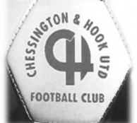
Paul ‘Nogsy’ Norris decided to step down after 10 years of Management. Enter Glynn Stephens as the manager. Glynn had been reserve team manager at Ashford Town (Middx) after a glittering playing career, amongst some of the top Ryman teams, so to take on this task must have been a daunting test as we’ve always recruited from within, but he took to it admirably & took the team to its second highest finish, 6th, since we entered this competition.

Four years later & sadly, Glynn found the going tough & halfway through the 20011/12 season, parted company with the Club. In for Glynn came once again……...Nogsy, who changed the team around in an effort to save the Club from relegation, but all in vain as we finished third from bottom, only Banstead Athletic & Mole Valley SCR were below us, but our fate was in the hands of a relegated Whyteleafe team who were bottom of Ryman South but decided not to come down to CCL but enter the Kent League leaving us free to continue our quest for success in this League!

2013/14, Paul Norris left the Club in October, leaving his assistant Andrew Ellis to pick up the pieces. Andrew brought in ex CHUFC player Darren Woods to assist him but to no avail as we were relegated to Division One finishing bottom of the Premier Division after flirting with that spot the previous two years.

Division One was probably a breath of fresh air & Darren & Andy took it on the chin & set out to earn promotion back to the Premier Division but with 19 games to play, it seemed a bridge too far until a run of just two defeats & two draws led to a dramatic final game of the season when, 1-3 down at HT v Alton Town & Worcester Park beating Banstead it all seemed in vain until a strange twist of fortune as the lads scored four 2nd half goals and Banstead won at Worcester Park to send us back to the Premier Division.

Every Opponent A-Z
Over the years we have played many, many different opponents. Exactly how many is a difficult question, as it all depends on your definition. Are Camberley & Yorktown different to Camberley Town, or are Epsom Town different to Epsom F.C. or Epsom & Ewell F.C.?

In my analysis I have classed them as the same team, and will work through them all from A to Z. Some we have played many times, whilst others we have met just once or twice. Enjoy!


Poole Town: Played 1 - W0 D0 L1 - F1 A3 - PPG - 0.00

Back in 1979 we were unfortunate to be rewarded for our F.A. Cup win at Arundel with a long trip to Dorset, where Southern League Poole Town were waiting. We were three down by half time and although Carl Stewart scored in the second half, that was all we could do and the Dolphins progressed 3-1.

That day we had visited the Dolphin Stadium, home of the Poole Town Speedway team, which was home for many years. However, in the nineties they were forced out and the club had to rebuild almost from scratch, sharing with local club Hamworthy United, before re-joining the Wessex League. They finally secured a new ground at Tatnam Farm, which having visited last season I can confirm has potential, although remains basic, especially as they now reside in the Southern Premier League. They lost out in the playoffs last season but remain a very powerful side these days and if the ground is improved, we could easily see them in the Conference South shortly.

Purfleet: Played 1 - W0 D0 L1 - F2 A3 - PPG - 0.00

Purfleet were a very new club when we met them in the Isthmian League Cup, being edged out by three goals to two. Their stadium is very near to the M25 and can clearly be seen just beyond the A13 junction. They raced up the Divisions before changing their name to Thurrock, although they have slipped back in recent seasons and currently play in the Ryman League Division One North.

Rainham Town: Played 25 - W7 D8 L10 - F43 A56 - PPG - 1.16 - Below Average

Just down the road from the Purfleet ground, we first met Rainham Town for a friendly on 21st January 1950, losing with a makeshift squad by five clear goals on our first ever visit to Deri Park.

We spent our days in the Corinthian League while they were principally in the Delphian League, one level below us. However, following the merger of those two Leagues with the Athenian League in 1963, just one relegation would place us together which happened to us in 1965.

Our first away game of the 1965/66 season was at Deri Park where a second half goal from Jimmy Wand (I’ve often wondered whether he was nicknamed the magician!) secured a 1-0 win and on 8th January 1966 we completed a double with a 4-1 win at West Street.

As many of our supporters know, the sixties were a terrible time for us and although we drew the 1966/67 league games, both played over the Bank Holiday August weekend, results started to deteriorate from that point. In the October we drew 2-2 after extra time in the Athenian League Division Two League Cup in Essex, only to lose the home replay 4-1 a month later.

Two defeats followed in 1967/68; most embarrassingly 5-0 at home on 20th January 1968 and although things improved the following season with a 3-1 home win and a 3-3 away draw, we drew two and lost two of our next four before suffering a 6-1 home defeat on 9th October 1971; Keith Ward’s second half goal proving little in the way of consolation.

Against expectations, goals from Barry Wiles and Johnny Eales enabled us to win 2-1 over there in

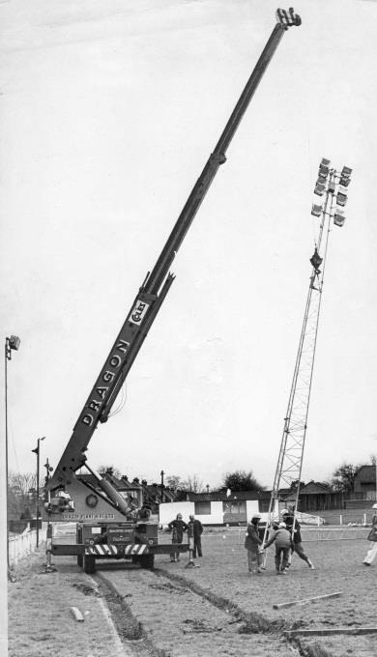
the return match that season. In our final season at that level in 1972/73, although we opened up the season with a decent 1-1 home draw, there was another heavy defeat in store at Deri Park, this time 5-1.

Upon our return to the Athenian League in 1975 Rainham were not there. Despite having been almost as poor as us over the previous ten years, they had been promoted, so we had to wait until the second half of the 1976/77 season, by which time we were also in the top Athenian flight, before we could do battle again. We won 6-2 at Deri Park on 29th January 1977 with Tommy Tuite scoring four times, although the return fixture was originally postponed on 19th March 1977 due to the West Street pitch being damaged by a crane that had sunk while trying to install our floodlights! (see picture right) When the match was finally played at the end of April Tuite scored again but we had to settle for a 1-1 draw after the visitors equalised.

Both sides were elected to the Isthmian League for 1977/78 and we would eventually be Champions, winning 3-0 away, although we were defeated 1-0 at home in January 1978.

Following our promotion we only met twice more; a 4-1 win at Deri Park in the League Cup in August 1980 was the first, but the second was far more memorable…

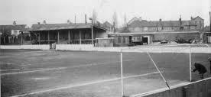
On 27th August 1991 we travelled to Rainham for another League Cup tie, only to enter the ground and be confronted by the strange sight of our players sitting in the stand. The game had been called off because the pitch had been damaged. Subsequently, methane deposits were discovered by professionals called in to value the ground from a development perspective and the ground was closed again, this time permanently. They still beat us 4-2 in the rearranged League Cup tie a week later at West Street but with no source of income whatsoever, they shared at Purfleet and Aveley before resigning from the League and folding in 1994. Ironically and despite contamination, the much vandalised ground was still eventually built upon around ten years ago.

Player Sponsorship
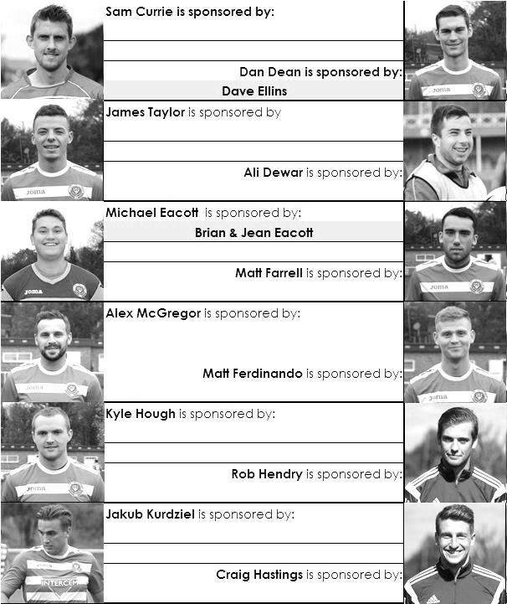

Here is the current list for the 2015/16 season showing all of our players and Management that are currently available for sponsorship this season.

Sponsorship costs just £40 and it is easy to do. Just select a player who has not been previously sponsored and let a Committee Member know that you would like to sponsor them. Beware though. Until we have received the money it is possible for someone to jump in front of you, so don’t delay, sponsor today!

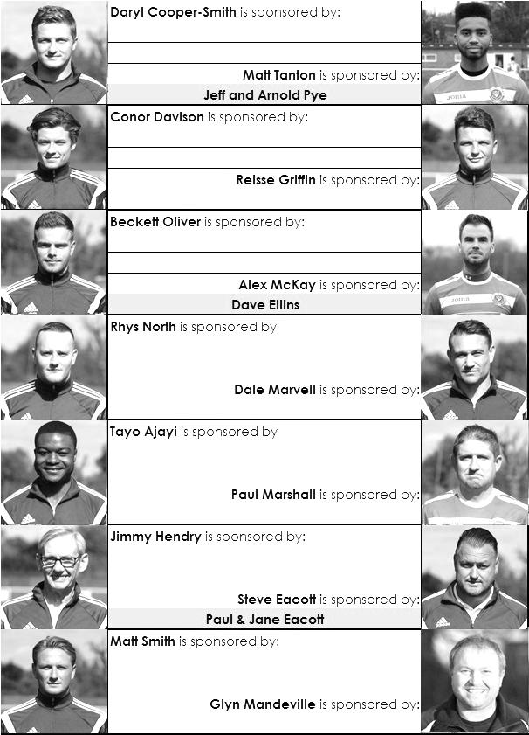

Surrey Senior Cup
Our successful Surrey Senior Cup winning team from 1981

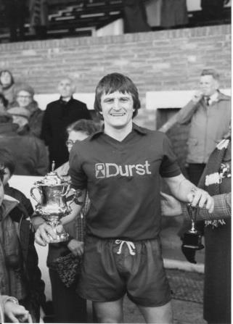
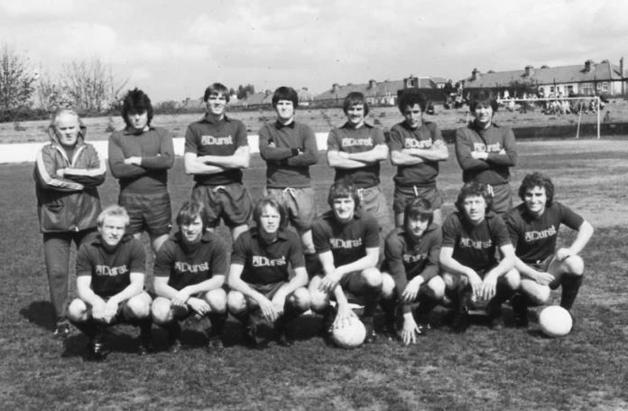
First Round
Ashford Town (Mx) | 3-1 | Beckenham Town
Camberley Town | 1-1 | Knaphill
Knaphill won 3-2 on penalties
Epsom & Ewell | 1-6 | Dorking Wanderers
Second Round
Knaphill | 1/12 | Ashford Town (Mx)
Chipstead | 4-1 | Chessington & Hook United
Colliers Wood United | V | Whyteleafe
Corinthian Casuals | 24/11 | Egham Town
Croydon | V | Farnham Town
Godalming Town | 10/11 | Guildford City
Horley Town | 1/12 | Badshot Lea
Leatherhead | V | Carshalton Athletic
Merstham | 1/12 | South Park
Met Police | 1/12 | Dorking Wanderers
Molesey | 1/12 | Raynes Park Vale
Redhill | V | Tooting & Mitcham United
Sutton United | 30/11 | Walton & Hersham
Walton Casuals | V | Kingstonian
Westfield | 1/12 | Chertsey Town
Woking | 10-0 | Sutton Common Rovers

EL Records Premier Challenge Cup
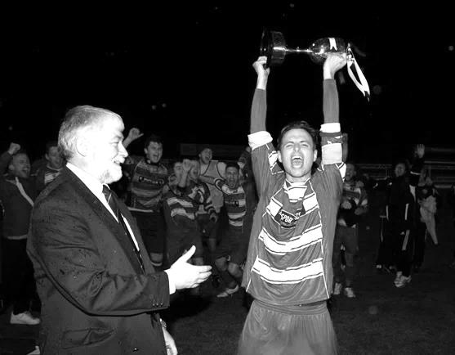
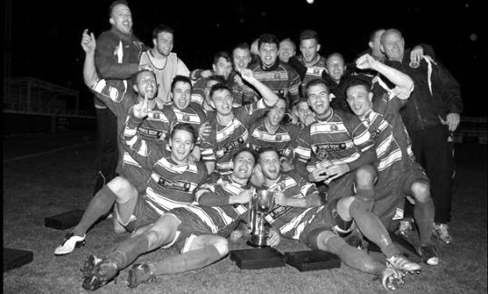
First Round
Farnham Town | 3-1 | Ash United
Horley Town | 4-1 | Staines Lammas
Windsor | 4-5 | Colliers Wood United
Redhill | 5-2 | Sandhurst Town
Sutton Common Rovers | 1-0 | Guildford City
Bedfont Sports | 1-3 | Abbey Rangers
Westfield | 3-1 | Farleigh Rovers
Second Round
Dorking Wanderers | 2-1 | South Park Reserves
Westfield | 1-0 | CB Hounslow United
Bedfont & Feltham | 1-5 | Colliers Wood United
Dorking | 0-3 | Knaphill
Badshot Lea | 2-4 | Spelthorne Sports
Hanworth Villa | 1-2+ | Chertsey Town
Ashford Town (Mx) | 2-1 | Epsom Athletic
Hartley Wintney | 4-2 | Horley Town
Banstead Athletic | 1-1+ | Epsom & Ewell
Epsom & Ewell won 7-6 on penalties
Sheerwater | 3-3+ | Frimley Green
Frimley Green won 8-7 on penalties
Farnham Town | 3-2 | Abbey Rangers
Camberley Town | 4-2 | Eversley & California
AFC Hayes | 0-1 | Banstead Athletic
Redhill | 3-0 | Sutton Common Rovers
Worcester Park | 1-5 | Chessington & Hook United
Cove | 1-6 | Cobham
Third Round
Camberley Town | 15/12 | Spelthorne Sports
Cobham | 15/12 | Frimley Green
Redhill | 15/12 | Farnham Town
Raynes Park Vale | 15/12 | Westfield
Epsom & Ewell | 12/1 | Ashford Town (Mx)
Colliers Wood United | 16/12 | Dorking Wanderers Reserves
Knaphill | 15/12 | Chertsey Town
Hartley Wintney | 15/12 | Chessington & Hook United

Match and Ball Sponsorships – 2015/16
Opponent | Date | Match and Match Ball Sponsor
Hoddesdon Town | 18/07/15 | Geoff Dyke
Windsor | 08/08/15 | Club President Stella Lamont
Erith & Belvedere (FAC) | 16/08/15 | Mike Lovett
Raynes Park Vale | 31/08/15 | EEFC Management Committee
Colliers Wood United | 08/09/15 | Bookham Building Shop – www.buildingshop.co.uk
AFC Hayes | 19/09/15 | John Bonner
Farnham Town | 26/09/15 | Ezara and Inaya Beddoe – our youngest supporters!
Chertsey Town | 17/10/15 | Club Media Officer – Richard Lambert
Dorking Wanderers (SSC) | 20/10/15 | Tony Ferdinando
Chessington & Hook United | 07/11/15 | Paul Merritt
Hanworth Villa | 21/11/15
Guildford City | 05/12/15
Cove | 08/12/15
Sutton Common Rovers | 19/12/15
Redhill | 02/01/16
Spelthorne Sports | 16/01/16
Hartley Wintney | 30/01/16
Bedfont Sports | 13/02/16
Horley Town | 27/02/16
Knaphill | 12/03/16
Westfield | 26/03/16
Badshot Lea | 09/04/16
Camberley Town | 16/04/16
Ashford Town (Mx) | 30/04/16
Ashford Town (Mx) (LC) | tba
For League, League Cup and Surrey Senior Cup Matches:
Match sponsorship - £40.00 Match ball sponsorship - £25.00. Combined £55.00.
For F.A. Cup and F.A. Vase matches:
Match sponsorship - £50.00 Match ball sponsorship - £30.00. Combined £65.00.

Sponsorship includes: (x2 for match, x3 for match and ball)

Admission, programmes, hospitality and advertising and mascot for the day (if required).
If you are interested, just speak to a Committee Member, or drop me an email at: richard.c.lambert@gmail.com


We also thank our Kit Sponsors INTERCEM

Salts Super Six Predictor
The Salts Super Six Predictor Competition is live again and the tickets are on sale at today’s game to the left of the gate. Five Premiership and one Championship fixture are on the list this afternoon.

The competition is easy to play! To win, you simply need to predict the results of the six matches correctly from the three options, fill in the form and make sure it is back with our sellers before the deadline on the ticket.

If you are a club regular, you just need to place your name on the sheet, although if you aren’t, then we’ll need a contact number from you too. We will announce any winners on the website within three working days, so don’t worry we won’t miss you!

The jackpot keeps rising and is already up to £297 How much higher will it go?

Please note that if there is more than one winner, the prize pot would be shared between the winners. All you need to do now is have a go, as many times as you like!

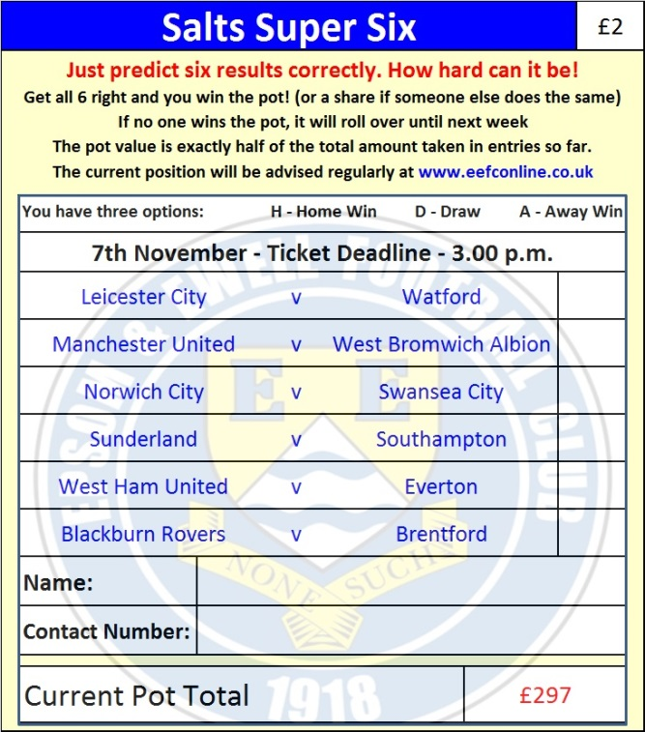

Good luck!

Combined Counties League – Premier Division
Saturday, 7th November 2015 - Kick-off 3.00 p.m.
Epsom and Ewell  (Royal Blue & White hoops) | V |  | Chessington & Hook  (All Yellow)
Squad | NUMBERS
Michael Eacott |  |  | Ian Hewitt
© Sam Currie |  |  | J Flack
Matt Tanton |  |  | Darren Titre-Wilson
Craig Hastings |  |  | James Duke
James Taylor |  |  | Bradley Duke
Dan Dean |  |  | Matthew Ellis
Alex McKay |  |  | Tyrone Newton
Matt Farrell |  |  | Sam Hewitt
Kyle Hough |  |  | Jimmy Hearne
Rob Hendry |  |  | Dan McLaughlin
Matt Ferdinando |  |  | Ahmed Hussain
Daryl Cooper-Smith |  |  | Scott Harrison
Beckett Oliver |  |  | Ade Oketoki
Tom Neale |  |  | David Amoah
Dale Marvell |  |  | Perry Weller
Alex McGregor |  |  | Listowel Appiah
Reisse Griffin |  |  | Joe Silverman
Rhys North |  |  | Ross Tomassi
Steve Rowe |  |  | Antony ‘Freddie’ Myers
Tayo Ajayi |  |  | Dan Coombes
Jakub Kurdziel |  |  | Jimmy Harding
Glyn Mandeville | MANAGER |  | Darren Woods
Matt Smith | ASSISTANT |  | Andy Ellis
Steve Eacott / Alex McKay / Jimmy Hendry | COACHES / PHYSIO |  | Russ Banyard / James Deacons / Chris Barker
REFEREE: S.Elson (Tongham)
ASSISTANTS: K.Corrick (Oxted), A.Bennett (Horsley)
Today’s Match and Match Ball are sponsored by
long serving supporter, Paul Merritt

OUR NEXT VISITORS TO HIGH ROAD
Hanworth Villa
Saturday 21st November 2015 - Kick-off 3.00 p.m.
Combined Counties League – Premier Division

